**Lab task #5**

Q1 Write down a Python program, using While loop that generates Odd no’s in between 1 to 100.

**INPUT:**

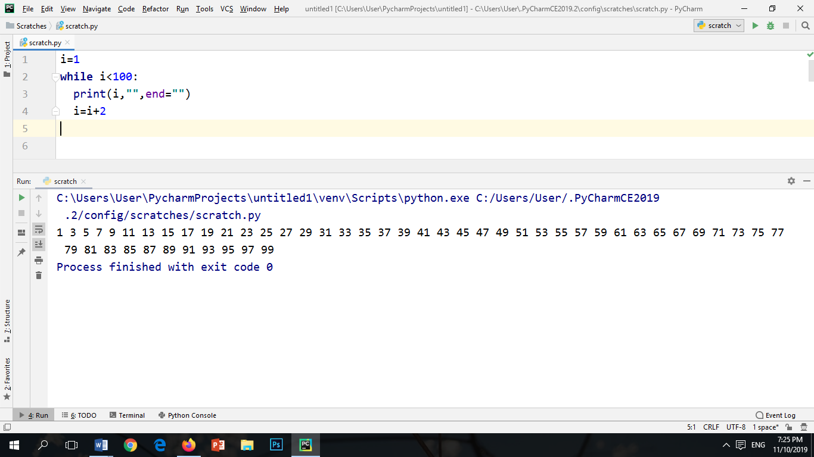

**OUTPUT:**



Q.2 Write down a Python Program using While loop to generate the following output.

1. **************

**************

**************

**************

**************

**************

**************

**************

**INPUT:**

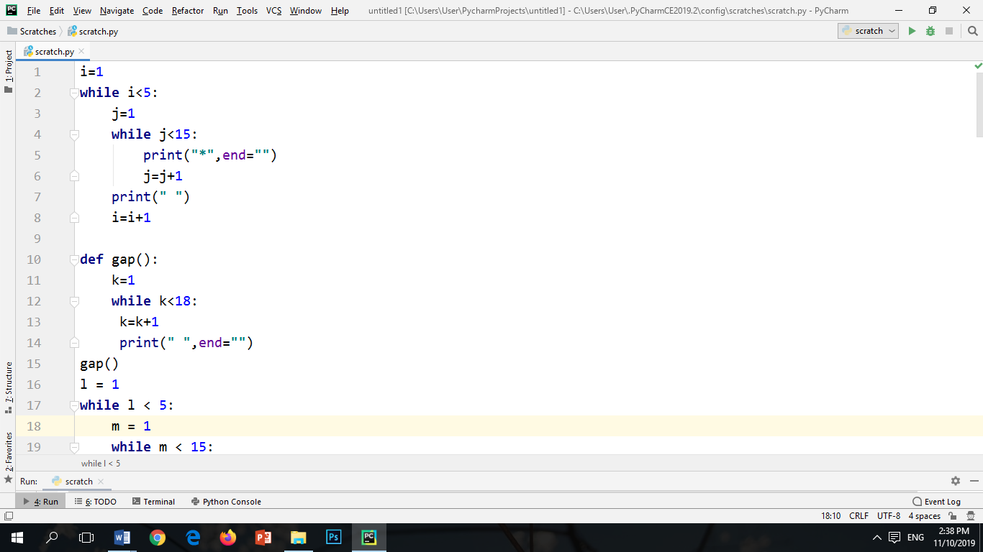

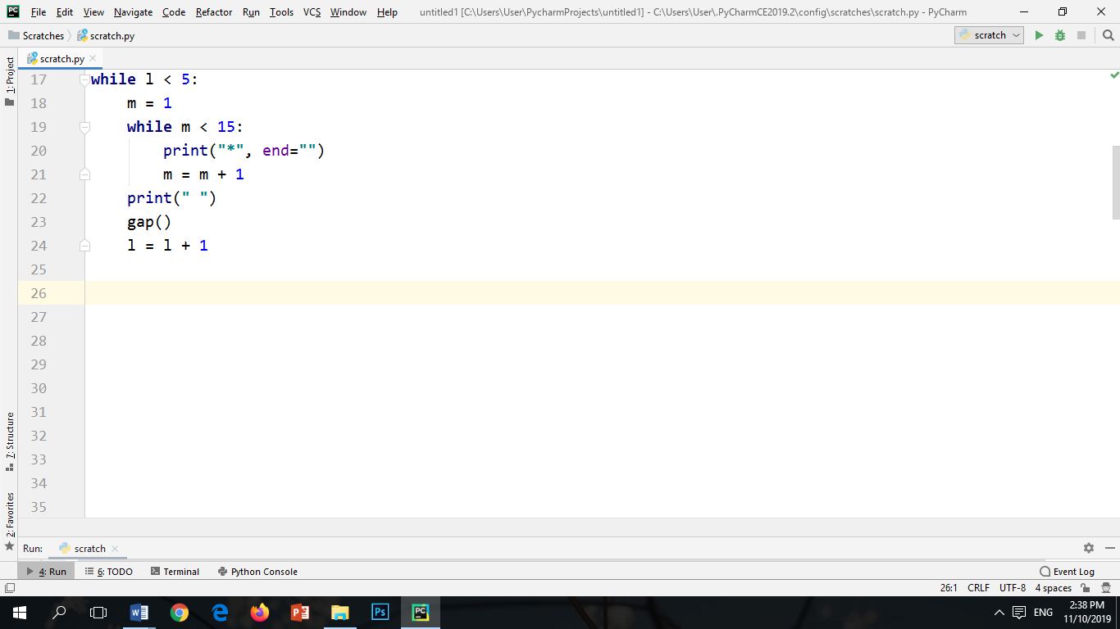

**OUTPUT:**

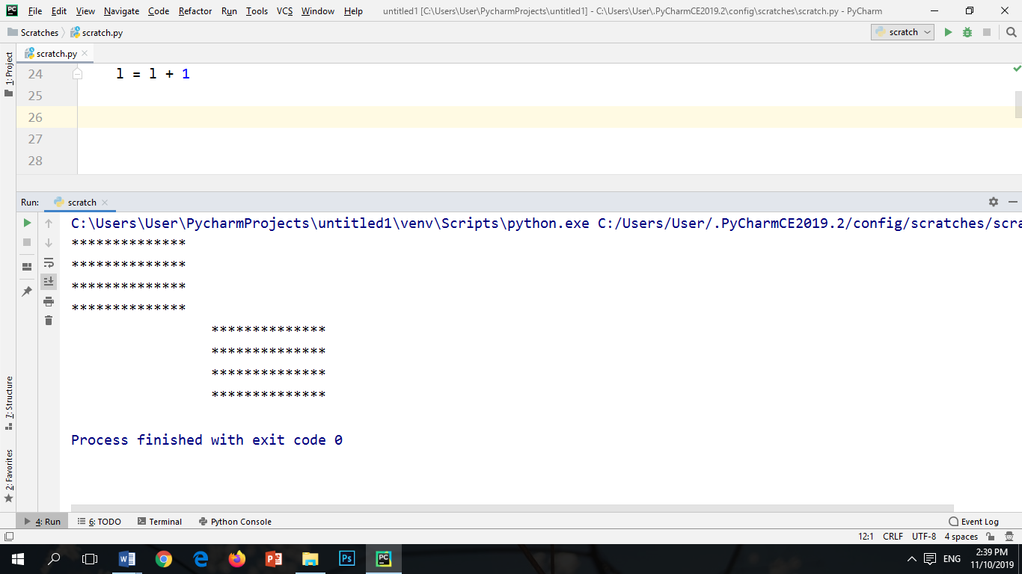

1. *

**

***

****

*****

******

*******

********

**INPUT:**

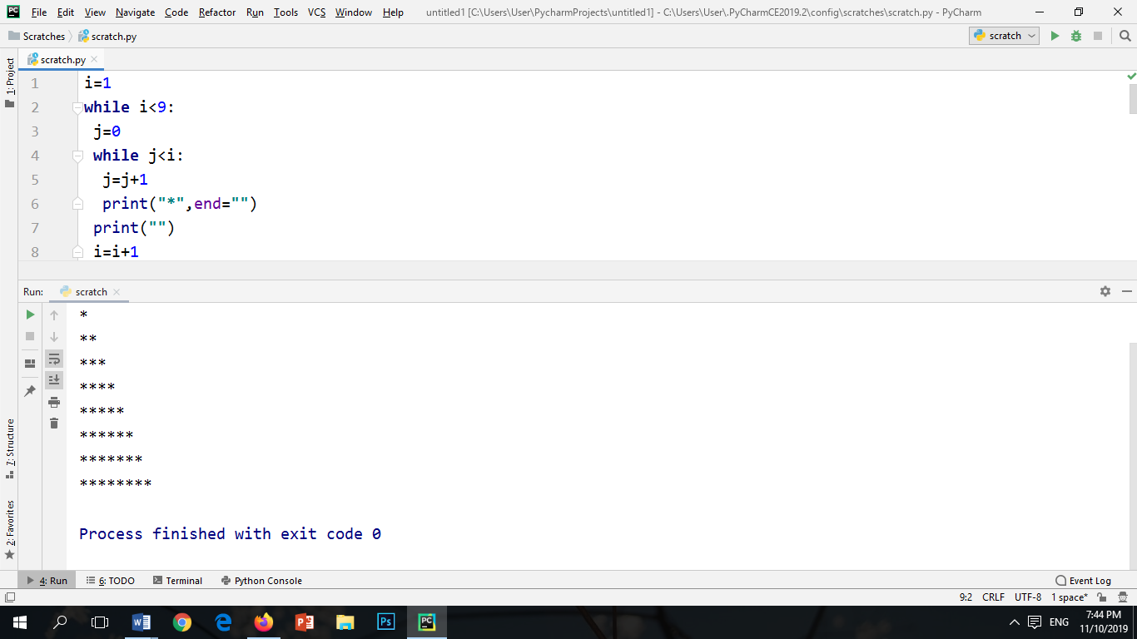

**OUTPUT:**



1. ********

*******

*****

****

***

**

*

**INPUT:**

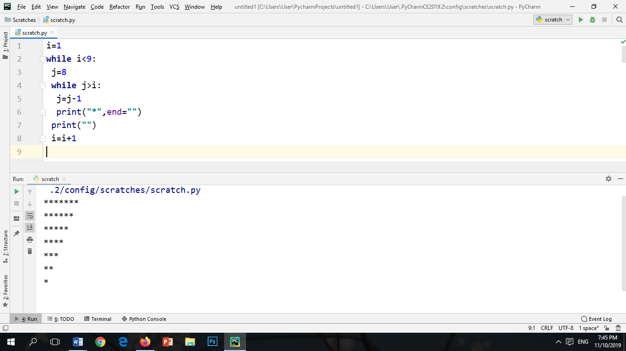

**OUTPUT:**

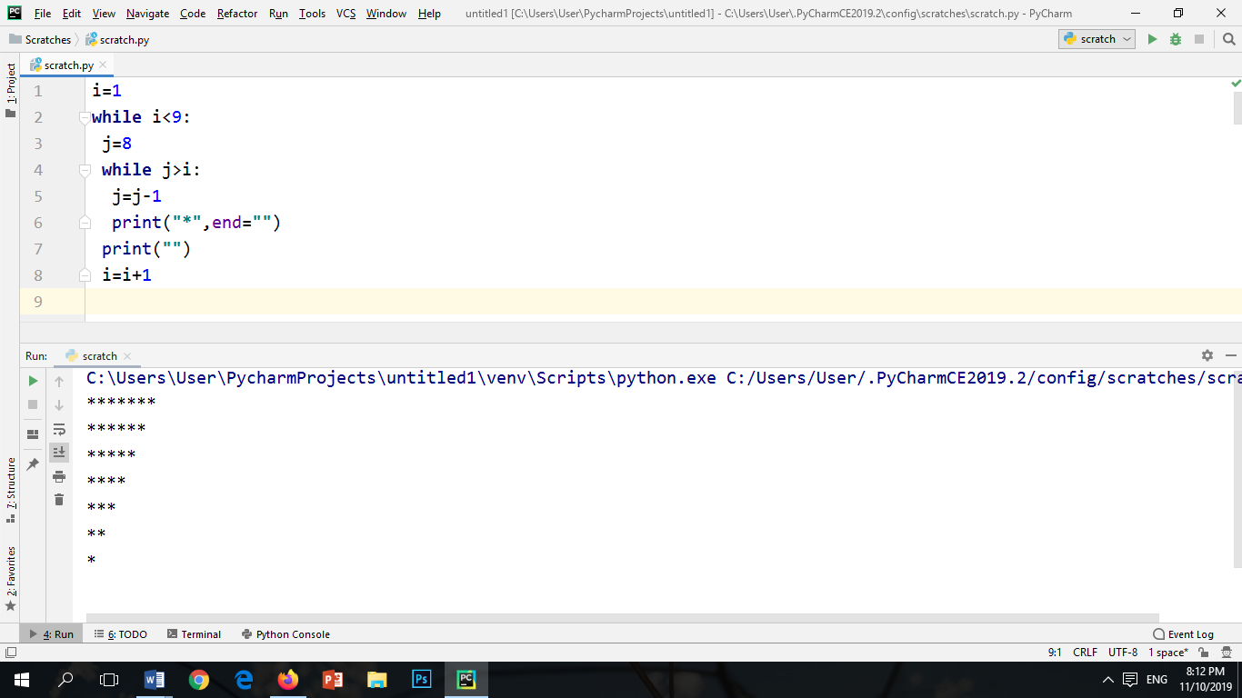

Q.3 Write down a python program having one function for calculating factorial of a no.

And call that function within a While loop to generate factorial of numbers from 0 to 10

**INPUT:**

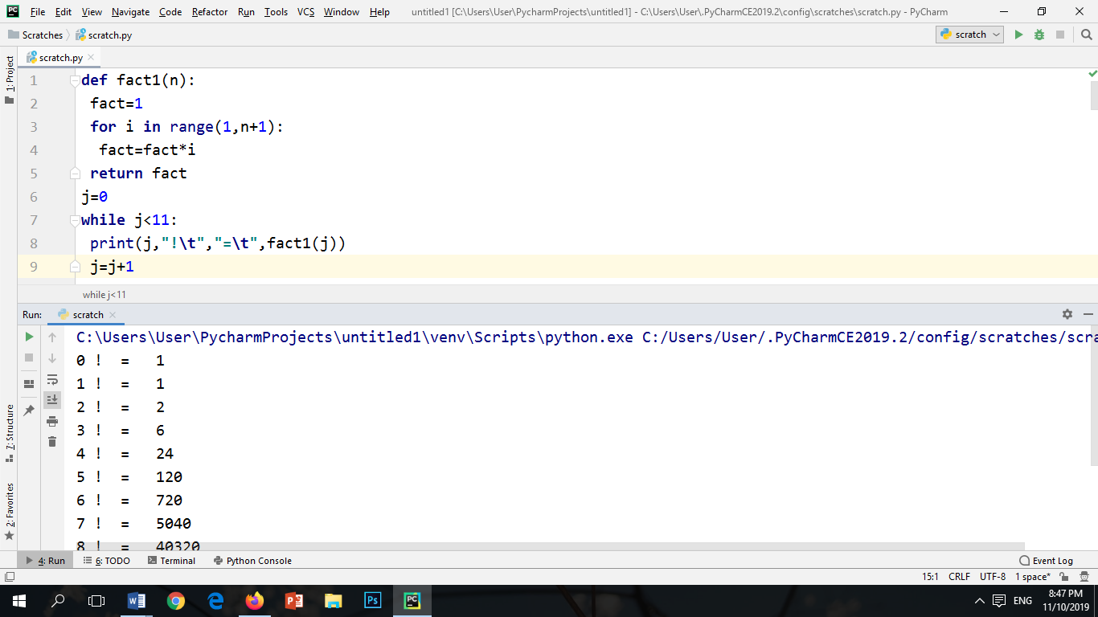

**OUTPUT:**

